一、【題目說明】：
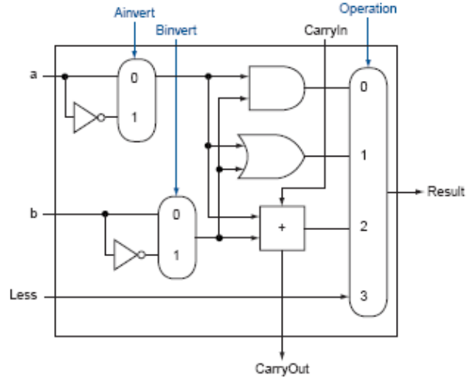
針對圖1所示之1-bit MIPS ALU電路，以module ALU_1bit描述圖1之電路。Basys2實驗板與圖1電路之對應如下：
圖1: 1-bit ALU
Basys2實驗板 | 圖1電路
SW0 | a
SW1 | b
SW2 | Less
SW3 | Ainvert
SW4 | Binvert
SW5 | CarryIn
SW7&6 | Operation
Led0 | Result
Led1 | CarryOut
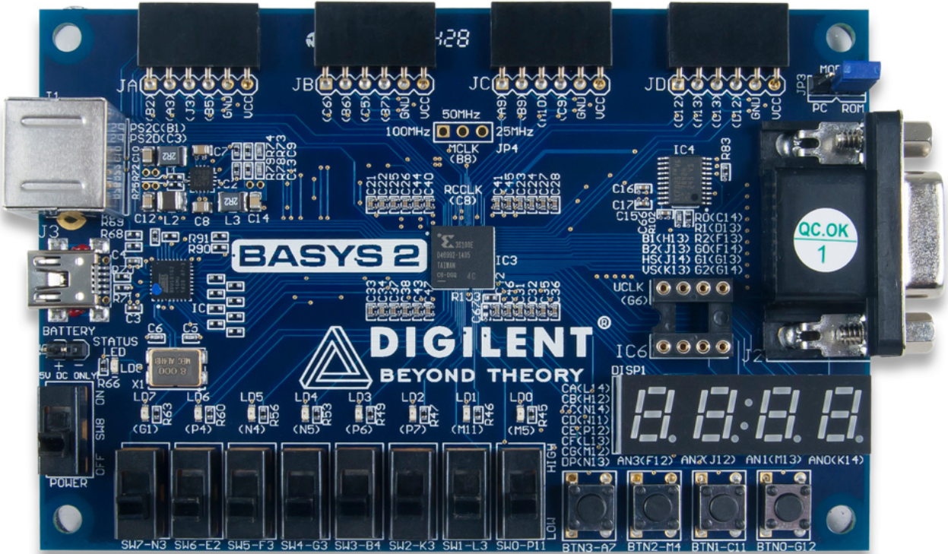
二、【電路設計與描述】：
Verilog code: (以下列code直接修改)：
module ALU_1bit(a, b, Less, CarryIn, Ainvert, Binvert, Operation,
Result, CarryOut);
input a, b, Less, CarryIn, Ainvert, Binvert;
input [1:0] Operation;
output Result, CarryOut;
wire ain,bin,andO,orO,sum;

MUX_2x1 MUX1(a, Ainvert, ain);
MUX_2x1 MUX2(b, Binvert, bin);
and andgate(andO, ain, bin);
or orgate(orO, ain, bin);
FA fulladder(ain, bin, CarryIn, sum, CarryOut);
MUX_4x1 MUX3(andO, orO, sum, Less, Operation, Result);

endmodule

module FA( // gate-level modeling
input x,y,z,
output S,C);

wire w1, w2, w3;

xor x1(w1, x, y);
xor x2(S, w1, z);
and a1(w2, x, y);
and a2(w3, w1, z);
or o1(C, w2, w3);
endmodule

module MUX_2x1( // Data flow modeling
input x,
input select,
output z);

assign y = ~x;
assign z = (select)? y: x;

endmodule

module MUX_4x1(
input a,b,c,d,
input [1:0]select,
output reg result
);

always @(a,b,c,d,select)
case(select)
2'b00 : result = a;
2'b01 : result = b;
2'b10 : result = c;
2'b11 : result = d;
endcase

endmodule

三、【電路合成與驗證】：
- 合成(Synthesize)後，使用View RTL Schematic觀察合成電路圖，點選top後進入下一層，將電路圖完全展開後，執行Zoom to full view，擷取電路圖畫面貼於下：
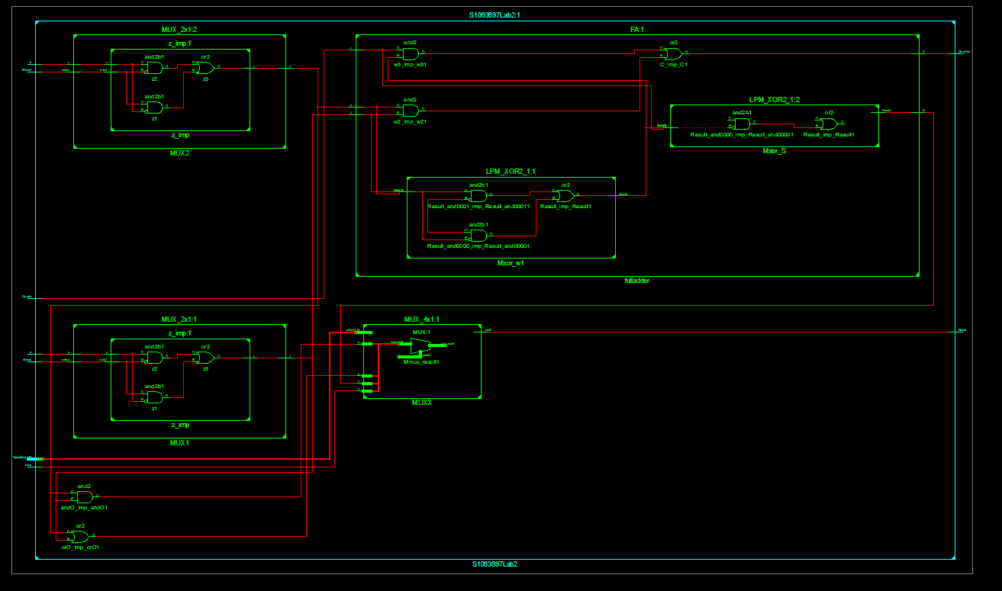
- 使用View Technology Schematic觀察合成電路圖，點選top後進入下一層，並將電路圖Zoom to full view，擷取電路圖畫面貼於下：
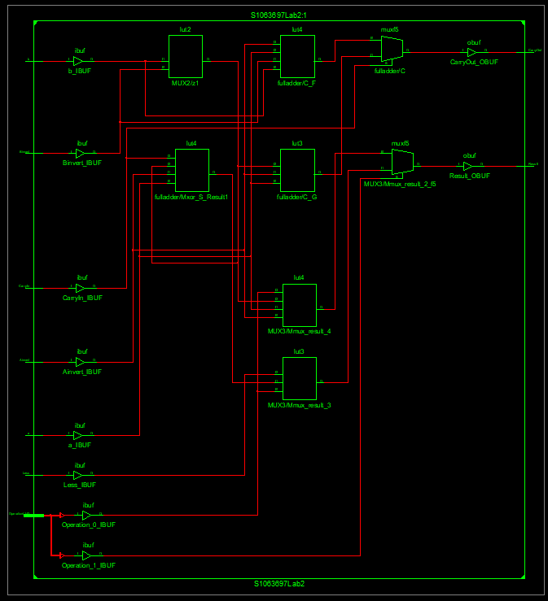

- 以ISE Synthesize後，根據下列測試模組進行ISim模擬，將模擬波形畫面截圖於下：

module ALU_1bit_tb; //測試模組
reg a,b,Less,CarryIn,Ainvert,Binvert;
reg [1:0] Operation;
wire Result,CarryOut;
ALU_1bit U0(a,b,Less,CarryIn,Ainvert,Binvert,Operation,Result,CarryOut);

//waveform
initial begin
a=1;b=0;Less=0;CarryIn=0;Ainvert=0;Binvert=0;Operation=0;
#5 Operation=1;
#5 Operation=2;
#5 Operation=3;
#10 a=1;b=1;Binvert=1;Operation=0;
#5 Operation=1;
#5 Operation=2;
#5 Operation=3;
#10 $finish;
end
endmodule
- 從Design Summary視窗觀察Synthesis Report，下拉至Final Report內容，擷取畫面貼於下：
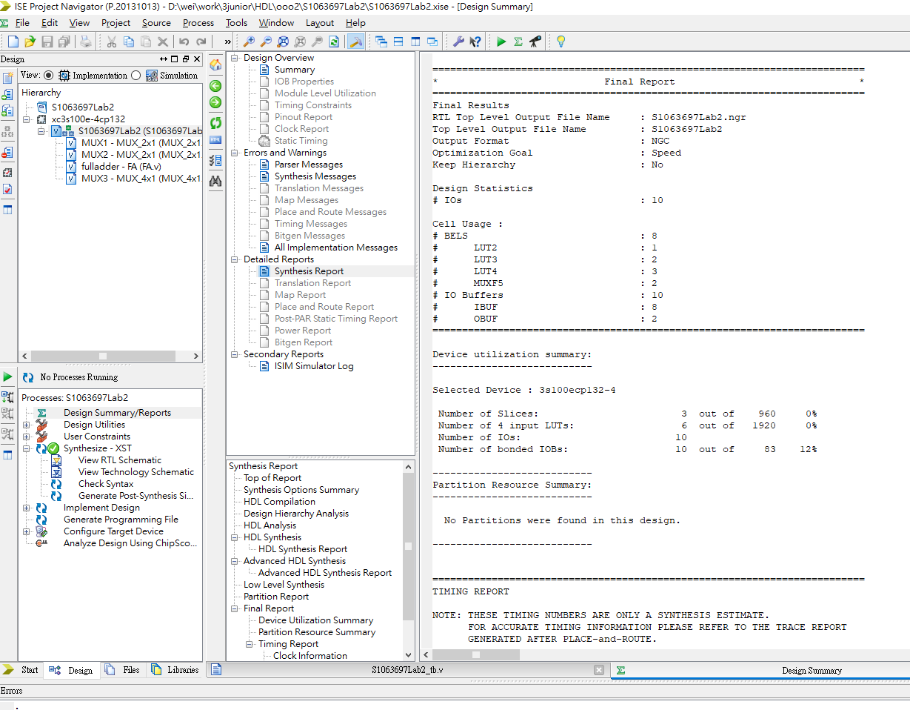
- 從Design Summary視窗觀察Synthesis Report，下拉至Timing Report內容，擷取畫面貼於下：
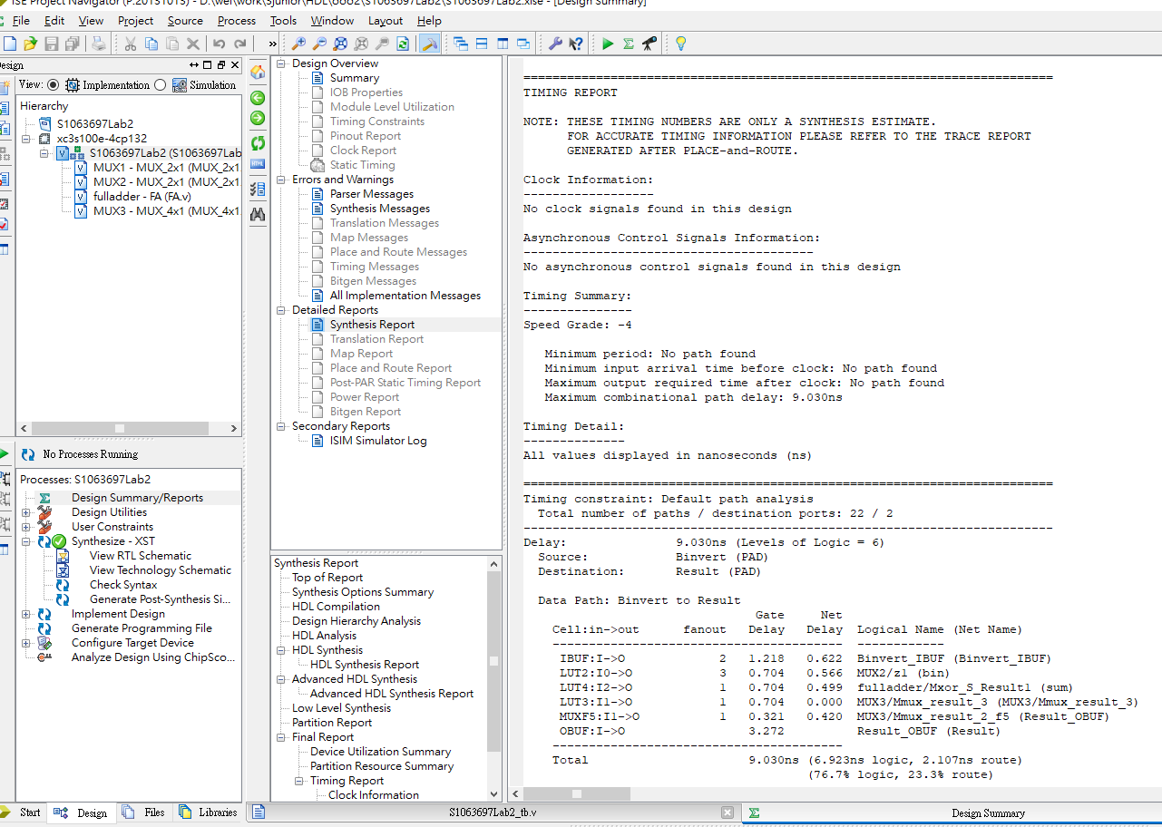
- 實現(Implement)電路後，開啟Design Summary視窗，擷取畫面剪下Project Status、Device Utilization Summary與Performance Summary三個表格。
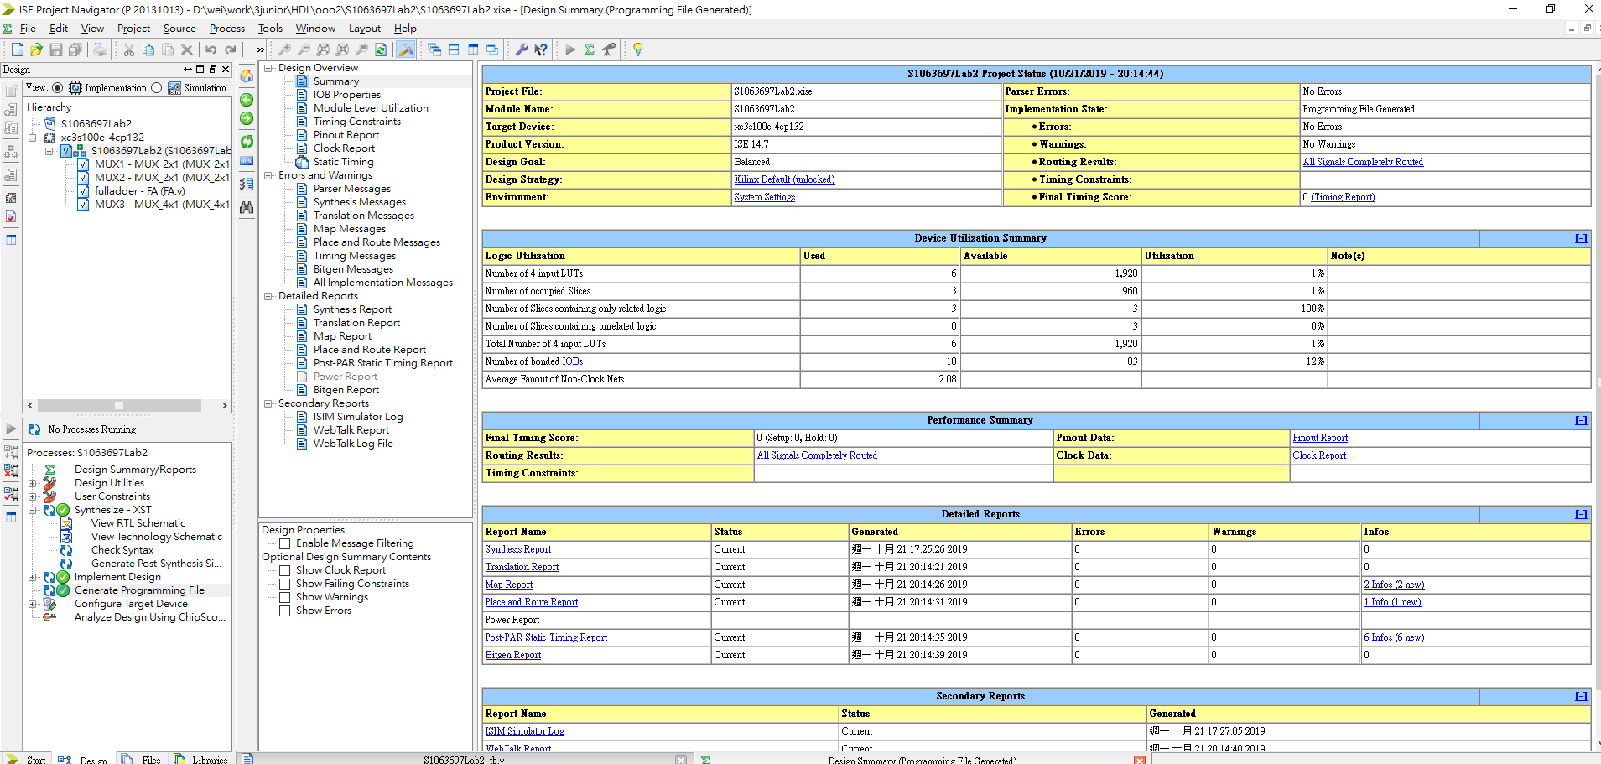
四、Basys2實驗板驗證與結果記錄：
A. 根據下表9組實驗操作組合，分別進行實驗與觀察，將Led0與Led1的值分別填入下表中。
Led亮:填入1，Led不亮:填入0。
Basys2實驗板 | 圖1電路 | 實驗操作組合
Basys2實驗板 | 圖1電路 | 1 | 2 | 3 | 4 | 5 | 6 | 7 | 8 | 9
SW0 | a | 0 | 0 | 0 | 0 | 1 | 1 | 1 | 1 | 1
SW1 | b | 0 | 1 | 1 | 1 | 0 | 0 | 0 | 0 | 0
SW2 | Less | 0 | 0 | 0 | 0 | 0 | 0 | 0 | 0 | 1
SW3 | Ainvert | 0 | 0 | 0 | 0 | 1 | 1 | 1 | 1 | 1
SW4 | Binvert | 0 | 0 | 0 | 0 | 1 | 1 | 1 | 1 | 1
SW5 | CarryIn | 0 | 0 | 0 | 0 | 1 | 1 | 1 | 1 | 1
SW7&6 | Operation | 00 | 00 | 01 | 10 | 00 | 01 | 10 | 11 | 11
Led0 | Result | 0 | 0 | 1 | 1 | 0 | 1 | 0 | 0 | 1
Led1 | CarryOut | 0 | 0 | 0 | 0 | 1 | 1 | 1 | 1 | 1
B. Basys2實驗板結果拍照展示：
根據學號最後一碼，如為1~9分別顯示對應實驗操作組合編號資料，
學號最後一碼為0者，顯示實驗操作組合編號9資料。
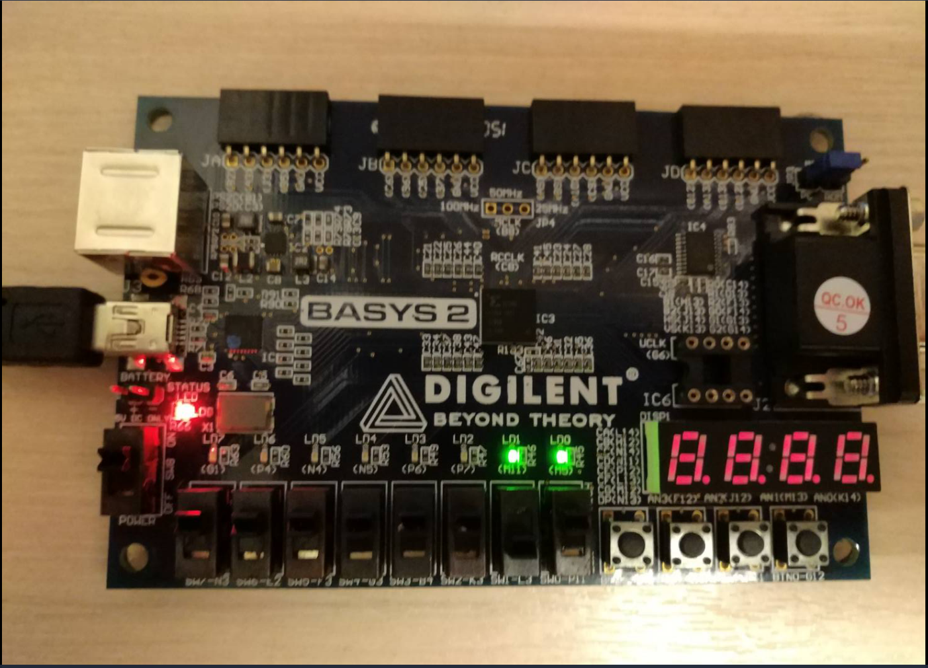
五、basys2.ucf(僅列出有使用的，註解部分移除)
# Pin assignment for LEDs
NET "CarryOut" LOC = "M11" ; # Bank = 2, Signal name = LD1
NET "Result" LOC = "M5" ; # Bank = 2, Signal name = LD0

# Pin assignment for SWs
NET "Operation[1]" LOC = "N3"; # Bank = 2, Signal name = SW7
NET "Operation[0]" LOC = "E2"; # Bank = 3, Signal name = SW6
NET "CarryIn" LOC = "F3"; # Bank = 3, Signal name = SW5
NET "Binvert" LOC = "G3"; # Bank = 3, Signal name = SW4
NET "Ainvert" LOC = "B4"; # Bank = 3, Signal name = SW3
NET "Less" LOC = "K3"; # Bank = 3, Signal name = SW2
NET "b" LOC = "L3"; # Bank = 3, Signal name = SW1
NET "a" LOC = "P11"; # Bank = 2, Signal name = SW0

